# MY MESSAGES

The **My Messages** tab allows you to communicate with your healthcare providers via Direct Messaging, a method for secure transmission of PHI (Protected Health Information) over the Internet.

The **Inbox** works similarly to most email applications. In the HIE, a user’s Direct address is that user’s HIE username followed by the system’s Direct Messaging address. For example, user “JSmith” would be “JSmith@direct.[HIE Domain Name].com”.

There are three folders which store direct messages: **Inbox**, **Sent**, and **Deleted**. Click on any of the folder names to access those folders.

Click the refresh button to check for new messages. To delete a message from a mailbox, select the checkbox beside the message and click the trashcan button.

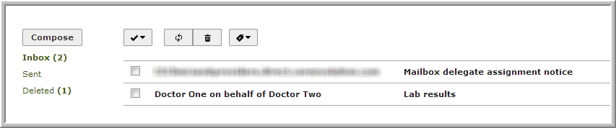

MDN messages can be filtered using the tag button on the far right of the toolbar. MDNs are special messages that contain information about whether Direct messages have been received or read. In general, you will want to filter MDN messages out of your inbox, and display only your incoming Direct messages.

To hide MDN messages in your inbox, click on the tag button, and select an option from the drop-down menu. Clicking on one of the check boxes will hide all messages of that MDN type.

To show MDN messages that have been previously hidden, uncheck the appropriate checkbox.

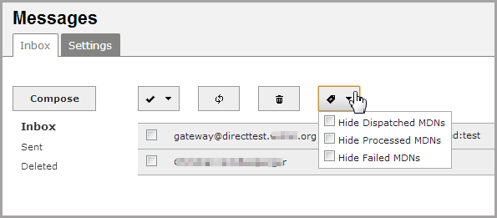

The upper right of the **Inbox** screen shows the Direct address of the user whose mailbox is currently displayed.

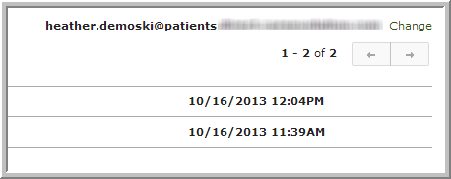

## COMPOSING A MESSAGE

To begin, click the **Compose** button to open a new message. To address the recipient, begin typing the first or last name of your provider. As you begin to type, the autocomplete feature will suggest matching users within your HIE. Click on the correct name and address to add it to the list of recipients.

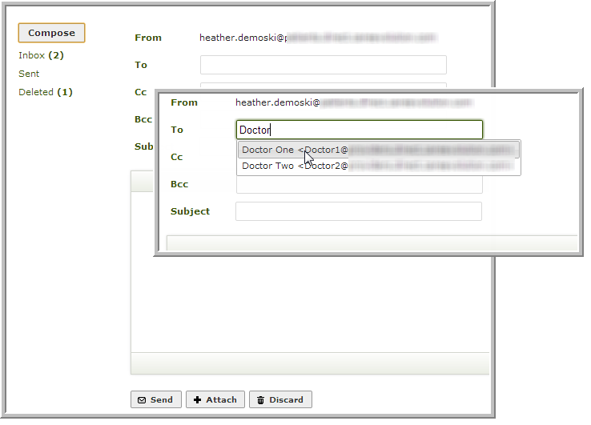

You will now see the selected address displayed below the *To*field. Click the **x** to the right of the address to delete it.

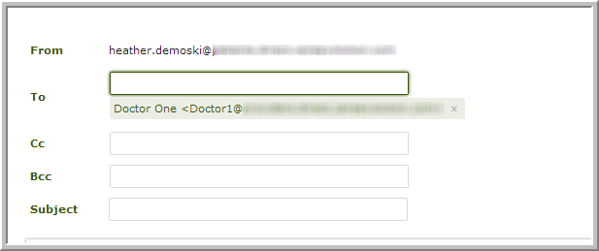

If you manually enter an address, HIEBus will automatically check to see if the domain is valid. If the address turns red, HIEBus was unable to verify the address, and your message will not be sent.

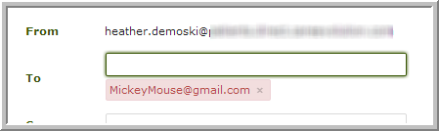

The toolbar contains tools for editing and customizing messages. A tooltip will appear when hovering the cursor over a toolbar icon. Collapse or expand the toolbar by clicking the arrow icon on the lower right.

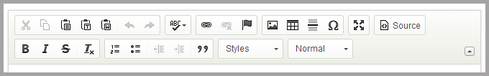

Use the **Attach** button to send files securely to your provider. NOTE: Each message will automatically contain identifying information about you to prevent mistaken identity and to ensure confidentiality.

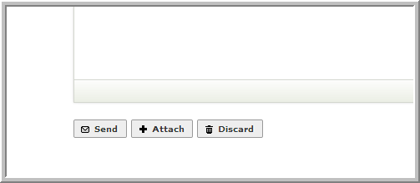

Click **Send** when finished with your message, or **Discard** to delete the draft.